Grade 3
Lost in Space

Description: | Students will:  Paint stars with one paint palette and a space ship with another palette.  Create a script using x increase by and y increase by tiles.  Discover that increase by a set amount in a ticking script is like making jumps, positive and negative on a number line.  Discuss the advantages and disadvantages of large and small numbers speed and accuracy.  Analyze relationships between the x and y values and the slope of the line.  Change numbers in a ticking script to develop control of the spaceship.  Use detailed watchers to observe the location of the spaceship.  Use detailed watchers to retrieve the spaceship if it leaves view.  Use a pen trail true statement to show the path the spaceship has traveled among the stars.  Create a reset script specifying x and y locations and clearing pen trails.  Develop skill navigating with x and y axis information.  Use digital and analog clocks to track the travel time.
Project View | 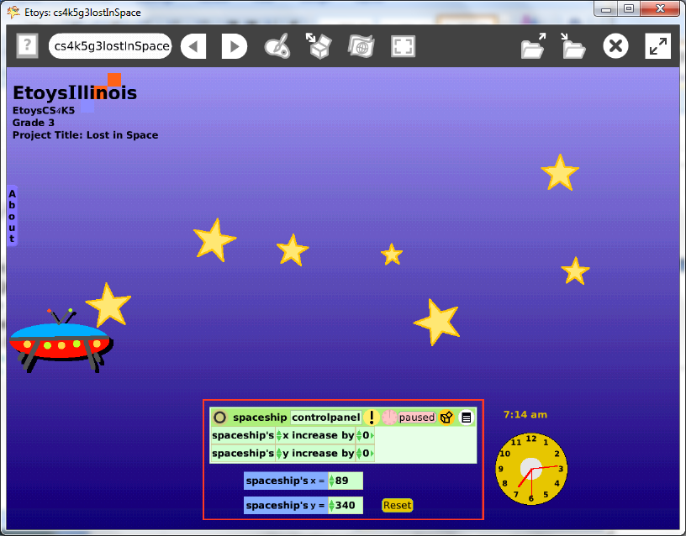
Subject: | Mathematics
Etoys Quick Guides | Click the question mark in Etoys to open the set of interactive tutorials for basic tools and techniques.
Vocabulary: | X axis, y axis, increase by, slope, positive integers, negative integers, number line, speed, time, digital, analog,
Lesson 1:  Paint Tools: Clean Edge Stars  Script Tiles: X and Y  Menus: Viewer Icons Set  Menus: Watchers  Navigator Bar: Keep Find Projects | Use a paint palette and paint a field of stars.  Use the world’s Viewer to change the color of the background. Fill and border provides interesting choices of gradient and radial fill.  Use a new paint palette to paint a spaceship.  Open a Viewer for the space ship and change the name from sketch to a meaningful name.  Create a script using the x and y tiles. Name this script Move.  Click the x and the y tiles’ arrow meaning ‘is’ to open a menu of four choices. Choose increase by for both tiles.  Start the script and chose a new value for x and for y.  Give students time to experiment with their project and with the controls these scripts provide. Give students time to see other projects and to share theirs. Discuss what they learn and give them time to modify their project.  If the spaceship travels out of sight, here are two ways to bring the ship back into sight. Click in the Viewer and change the value for x and y to bring the ship back to a specified location. For example x<- 100 and y<- 100.  Or, use the white menu in the top border of the Viewer and click grab me to retrieve a lost space ship.  Use the white menu to the right of the spaceship’s x tile and the y tile in the Viewer and choose detailed watcher for a tile to monitor the spaceship’s location. Close the Viewer and try the project.  Keep the project: nameSpaceship.
Lesson 2:  Script Tiles: Pen Use  Menus: Scriptor Icons Set | Add a pen trail to the script that makes the spaceship move and ask students to steer from one star to another.  Make a reset script that includes starting locations specified with x and y values and a tile to clear all pen trails. Name this script Reset.  Click on the white menu in the top border of the Scriptor and choose: make a button to fire this script.  Ask students to drive their spaceship to create a perimeter around their star field.  Give students time to develop skill navigating with the script ticking. Challenge them to pass each star so that the pen trail goes under the star and return to the starting point with the script ticking the whole time.  Keep the project.
Lesson 3: | Add digital and analog clocks from the Object Catalog: Just for Fun.  Change the color of the clocks.  Copy the clocks with a grab patch tool to show the game’s start time.  Give the students time to try others’ projects.  Ask them to estimate the level of difficulty from looking at the star field and the given values for x and y.  Challenge them to circle at least half of the stars in the project and return to the starting point.  Suggest that planning a route in advance will improve their chances of success.  Give them time to plan and to try and to enjoy. Discuss.
Standards: | Common Core Standards  Mathematics: 3.NF.3.d; 3.MD.1  Bloom’s Taxonomy/Cognitive Domain:  Knowledge: knows, selects  Comprehension: estimates  Application: demonstrates, uses, constructs, changes, discovers  Analysis: analyzes, compares, experiments  NETS  1. a, b, c  2. a  3. a, b, c, d  5. a
Resources: | Etoys Help Quick Guides: always available in Etoys. Open Etoys and click the question mark to open a set of interactive tutorials of basic tools and techniques.  www.etoysillinois.org projects, lesson plans, software download  www.mste.Illinois.org more math, science, and technology resources  www.corestandards.org Common Core Standards  www.squeakland.org software and Etoys projects  www.nctm.org Standards and Focal Points for each grade level
Kh January 2011

